Cairo University
Faculty of Graduate Studies for Statistical Research.
Department of Computer and Information Sciences.

Salamtak System

Submitted by
- Mohamed Ibrahim Elsaid Zoair

Supervised by
Dr. zeinab Ezz

Cairo, Egypt

2025 / 2026

CONTENTS
Acknowledgment
Abstract
Chapter 1: Introduction
1.1 Introduction
1.2 Scope
1.3 Purpose
1.4 System Architecture
Chapter 2: System Requirements Specification
2.1 Introduction
2.2 Functional Requirements
2.3 Requirement Specifications
2.4 User Stories
2.5 Work Backlog
2.6 Project Duration
2.7 Use Case Diagram
2.8 Actor Description
2.9 Use Case Description
2.10 Traceability Matrix
2.11 Activity Diagrams
2.12 Sequence Diagrams
2.13 Non-Functional Requirements

Chapter 3: System Design
3.1 Introduction
3.2 Component Diagram
3.3 Class Diagram
3.4 Entity Relationship Diagram (ERD)
3.5 Database Mapping
3.6 Summary
Chapter 4: System Implementation and Testing
4.1 Introduction
4.2 Development Environment
4.3 System Implementation
4.4 Login Module
4.5 Registration Module
4.6 Admin Dashboard
4.7 Doctor Dashboard
4.8 Pharmacist Dashboard
4.9 Patient Dashboard
4.10 Database Implementation
4.11 Testing (User Acceptance Test)
4.12 Test Cases
4.13 Summary
Chapter 5: Conclusion and Future Work
5.1 Conclusion
5.2 Future Work
References

Acknowledgment

We extend our sincere gratitude and profound appreciation to Cairo University / Faculty of Postgraduate Studies in Statistical Research for the distinguished academic and scientific support they provided throughout our study period, and for offering an educational environment that contributed to the development of our knowledge and the enhancement of our skills.

We also express our heartfelt thanks to the esteemed faculty members for their sincere efforts and fruitful scientific guidance, whose directions played a significant role in the successful completion of this project.

We pray to Almighty Allah to reward them abundantly on our behalf and to grant them continued success in their academic journey.

Abstract

The healthcare sector requires efficient and organized systems to manage patient information, appointments, medical records, and pharmacy services. Traditional manual methods often lead to delays, data loss, and communication difficulties between healthcare providers and patients. To address these challenges, the Salamtak Healthcare Management System was developed as a web-based platform that integrates patients, doctors, pharmacists, and administrators into one centralized system.

The system is designed using the Flask Framework with Python for backend development and SQL Server for database management. It provides secure

authentication and role-based access control for different types of users. Patients can register and book appointments, doctors can manage consultations and patient records, pharmacists can handle medicines and prescriptions, while administrators supervise system operations and user management.

The main objective of this project is to improve healthcare service efficiency, reduce paperwork, and enhance communication between all parties involved. The system also ensures secure storage and retrieval of medical data through a structured database design based on the Entity Relationship Diagram (ERD).

The project demonstrates the practical application of web development, database management, and software engineering concepts in solving real-world healthcare problems. Future enhancements may include online payment systems, video consultations, mobile application support, and artificial intelligence features for smarter healthcare services.

Chapter 1
Introduction

  - Introduction

Healthcare systems are evolving rapidly with the advancement of technology and digital transformation. Traditional methods of managing patient records, appointments, and medical services often lead to delays, inefficiency, and difficulties in communication between patients, doctors, and pharmacists. To overcome these challenges, healthcare organizations are increasingly adopting smart medical management systems that improve the quality and accessibility of healthcare services.

The proposed project, Salamtak Healthcare Management System, is a web-based application developed to facilitate communication and management within the healthcare environment. The system allows patients to register, book appointments, and access healthcare services online. Doctors can manage patient information and appointments efficiently, while pharmacists can organize medicine-related services. Administrators supervise the entire system and manage user accounts and permissions.

The system is developed using modern technologies such as Flask Framework and SQL Server Database to ensure reliability, security, and ease of use. This project aims to provide a user-friendly platform that enhances healthcare management and reduces administrative workload.

1.2 Scope
The scope of the Salamtak Healthcare Management System includes managing the core healthcare operations through a centralized web application. The system supports multiple types of users including administrators, doctors, pharmacists, and patients.

The main functions of the system include:

- User registration and login authentication.
- Managing user roles and permissions.
- Appointment booking and scheduling.
- Managing patient information and medical records.
- Medicine and pharmacy management.
- Dashboard and statistical reports for administrators.
- Secure data storage and retrieval using SQL Server.

The system is designed for educational and small-to-medium healthcare environments and can be expanded in the future with additional features such as online payment, video consultation, and AI-based diagnosis support..

1.3 Purpose
The purpose of the Salamtak Healthcare Management System is to simplify and improve healthcare service management by providing a digital platform for patients, doctors, pharmacists, and administrators.

The project aims to:
- Reduce manual paperwork and administrative tasks.
- Improve communication between healthcare providers and patients.
- Provide faster and more organized appointment management.
- Enhance data accuracy and accessibility.
- Ensure secure handling of medical and personal information.
- Increase efficiency in healthcare operations.

This system also serves as an educational project that demonstrates the use of web development technologies, database management systems, and software engineering concepts in real-world healthcare applications.

1.4 system architecture
client-server architecture model.
The Salamtak Healthcare Management System follows a client-server architecture model. The system consists of three main layers:

- Presentation Layer (Frontend):
The user interface developed using HTML, CSS allows users to interact with the system through web pages.
- Application Layer (Backend):
The backend is developed using the Flask Framework in Python. It processes user requests, manages business logic, handles authentication, and connects the frontend with the database.
- Database Layer:
SQL Server Database is used to store user accounts, appointments, medical information, and medicine records securely.

The architecture ensures efficient communication between system components while maintaining scalability, security, and maintainability.

Chapter 2
System Requirements Specification

2.1 Functional Requirements
The Salamtak Healthcare Management System provides several functions that support healthcare management activities. The system serves four main user roles: Administrator, Doctor, Patient, and Pharmacist.

Administrator Functions
- Login to the system.
- Add new users.
- View all users.
- Manage doctors.
- Manage departments.
- Manage appointments.
- Manage medicines.
- View prescriptions.
- Update and delete records.

Doctor Functions
- Login to the system.
- View dashboard statistics.
- View assigned patients.
- View appointments.
- Create prescriptions.
- Manage prescriptions.

Patient Functions
- Register a new account.
- Login to the system.
- Book appointments.
- View appointments.

- View prescriptions.
- View medical reports.
- Update profile information.

Pharmacist Functions
- Login to the system.
- Manage medicines inventory.
- Add medicines.
- Update medicines.
- Delete medicines.
- View prescriptions.

2.2 Requirement Specifications

ID | Requirement | Description
FR-01 | User Authentication | Users must login using username and password
FR-02 | User Registration | Patients can create new accounts
FR-03 | Role Management | Different dashboards based on role
FR-04 | Appointment Management | Patients can book appointments
FR-05 | Prescription Management | Doctors can create prescriptions
FR-06 | Pharmacy Management | Pharmacists manage medicines
FR-07 | Search Functionality | Search doctors, departments, appointments, prescriptions
FR-08 | User Management | Admin can add, update and delete users

2.3 User Stories

Patient
ID | User Story
US-01 | As a patient, I want to register so that I can access healthcare services.
US-02 | As a patient, I want to login so that I can access my account.
US-03 | As a patient, I want to book appointments with doctors.
US-04 | As a patient, I want to view my prescriptions.
US-05 | As a patient, I want to view my medical reports.

Doctor
ID | User Story
US-06 | As a doctor, I want to view appointments.
US-07 | As a doctor, I want to manage prescriptions.
US-08 | As a doctor, I want to view my patients.

Pharmacist
ID | User Story
US-09 | As a pharmacist, I want to manage medicines stock.
US-10 | As a pharmacist, I want to view prescriptions.

Administrator
ID |  | User Story
US-11 | As an administrator, I want to manage users.
US-12 | As an administrator, I want to manage departments.
US-13 | As an administrator, I want to monitor appointments.

2.4 Work Backlog

Priority | Task
High | User Authentication
High | Patient Registration
High | Appointment Management
High | Prescription Management
Medium | Pharmacy Management
Medium | Dashboard Statistics
Medium | Search Functions
Low | Reports and Analytics

2.5 Project Duration
Phase |  | Duration
Requirements Gathering |  | 2 Weeks
System Analysis |  | 2 Weeks
Database Design |  | 1 Week
UI Design |  | 2 Weeks
Backend Development |  | 4 Weeks
Testing |  | 2 Weeks
Documentation |  | 2 Weeks
Total Duration: 15 Weeks

2.6 Use Case Diagram
Actors:
- Administrator
- Doctor
- Patient
- Pharmacist
Main Use Cases:
Administrator
- Login
- Manage Users
- Manage Doctors
- Manage Departments
- Manage Appointments
- Manage Medicines
- View Prescriptions
Doctor
- Login
- View Patients
- View Appointments
- Create Prescription
Patient
- Register
- Login
- Book Appointment
- View Prescriptions

Pharmacist
- Login
- Manage Medicines
- View Prescriptions

2.7 Actor Description

Actor | Description
Administrator | Controls the entire system and manages users
Doctor | Manages patients, appointments and prescriptions
Patient | Books appointments and accesses healthcare services
Pharmacist | Manages medicines and prescriptions

2.8 Use Case Description
Use Case: Login
Item | Description
Use Case Name | Login
Actor | All Users
Preconditions | User account exists
Main Flow | User enters username and password
Alternative Flow | Invalid credentials
Postconditions | User redirected to dashboard

Use Case: Book Appointment

Item | Description
Use Case Name | Book Appointment
Actor | Patient
Preconditions | Patient logged in
Main Flow | Select doctor and appointment date
Postconditions | Appointment stored in database

2.9 Traceability Matrix

Requirement | Use Case | Test Case
FR-01 | Login | TC-01
FR-02 | Register | TC-02
FR-03 | Manage Users | TC-03
FR-04 | Book Appointment | TC-04
FR-05 | Create Prescription | TC-05
FR-06 | Manage Medicines | TC-06

Create activity diagrams for:
5.1 Activity Diagram – Login Process

Description
This diagram describes how a user logs into the Salamtak system.

+-------+
| Start |
+-------+
|
v
Enter Username
and Password
|
v
Submit Login
Request
|
V

Validate Credentials
|
+---+---+
| Valid?|
+---+---+
|
Yes ---------------- No
| |
v v
Determine Role Display Error
(Admin/Doctor/ Message
Pharmacist/Patient) |
| |
v |
Open Dashboard <-------+
|
v
End

5.2 Activity Diagram – Registration Process

Description
This diagram describes patient account creation.
+-------+
| Start |
+-------+
|
v
Open Registration
Form
|
v
Enter Personal
Information
(Name, Email,
Phone, Gender,
Birth Date)
|
v
Enter Password

and Confirm Password
|
v
Submit Form
|
v
Validate Input Data
|
+---+---+
| Valid? |
+---+---+
|
Yes ----------- No
| |
v v
Create User Show Error
Account Message
| |
v |
Registration <----+

Successful
|
v
Redirect to Login
|
v
End

5.3 Activity Diagram – Appointment Booking Process

Description
Represents how a patient books an appointment with a doctor.
+-------+
| Start |
+-------+
|
v
Patient Login
|
V

Open Appointment
Page
|
v
View Available
Doctors
|
v
Select Doctor
|
v
Choose Date
and Time
|
v
Submit Appointment
Request
|
V

Check Availability
|
+---+---+
| Available? |
+---+---+
|
Yes -------- No
| |
v v
Save Display
Appointment Another Time
| |
v |
Show Success <-+
Message
|
v
End

5.4 Activity Diagram – Prescription Creation Process

Description
Represents how a doctor creates a prescription for a patient.

+-------+
| Start |
+-------+
|
v
Doctor Login
|
v
Open Patient
Records
|
v
Select Patient

|
v
View Appointment
Details
|
v
Enter Diagnosis
and Medicines
|
v
Create Prescription
|
v
Save Prescription
to Database
|
v
Prescription

Available for
Patient and
Pharmacist
|
v
End

5.5 Activity Diagram – Medicine Management Process

Description
Represents pharmacy stock management performed by the pharmacist.
+-------+
| Start |
+-------+
|
v
Pharmacist Login
|
V

Open Medicine
Management Page
|
v
Select Action
(Add / Update /Delete Medicine)
|
v
Enter Medicine
Information
|
v
Submit Changes
|
v
Validate Data
|
+---+---+

| Valid? |
+---+---+
|
Yes -------- No
| |
v v
Update Display
Database Error
| |
v |
Show Success <-+
Message
|
v
End

2.11 Sequence Diagrams
Create sequence diagrams for:
Sequence Diagram – Login Process

Participants
- User
- Login Page
- Flask Application
- SQL Server Database
- Dashboard

Sequence Flow
User Login Page Flask App SQL Server Dashboard
| | | | |
| Open Login Page | | | |
|-----------------> | | | |
| Enter Username & Password | | |
|-----------------> | | | |
| Submit Login | | |
| |------------->| | | | |
| | | Validate User |
| | |-------------> |

| | |<------------- |
| | | User Found | |

| | | | | |
| |<-------------| Authentication Success
| | | | | |
| Redirect to Dashboard | | | |
|----------------------------------------------->|
| | | | | |
| Display Dashboard | | | |
|<-----------------------------------------------|

Figure Caption
Figure 5.6: Sequence Diagram for Login Process

Sequence Diagram – Appointment Booking Process

Description
represents how a patient books an appointment.

Participants
- Patient
- Appointment Form
- Flask Application
- SQL Server Database

Patient Appointment Form Flask App SQL Server
| | | |
| Open Form | | |
|------------------>| | |
| Select Doctor | |
| Select Date | |
| Submit Booking | |
|------------------------>| | |
| | Send Request | |
| |-----------------> | |
| | | Save Booking |
| | |-------------> |
| | |<------------- |

| | | Booking Saved |
| |<-----------------| | |
| Confirmation | | |
|<--------------- | | |

Figure Caption
Figure 5.7: Sequence Diagram for Appointment Booking Process

Sequence Diagram – Prescription Creation Process

Description
Shows how a doctor creates a prescription for a patient.

Participants
- Doctor
- Prescription Form
- Flask Application
- SQL Server Database

Sequence Flow
Doctor Prescription Form Flask App SQL Server
| | | |
| Open Patient | | |
| Record | | |

|---------------> | | |
| Enter Diagnosis | | |
| Enter Medicines | | |
| Submit | | |
|---------------> | | |
| | Save Prescription | |
| |-----------------> | |
| | | Insert Data |
| | |-------------> |
| | |<------------- |
| | | Success |
| |<----------------- | |
| Prescription Created | |
|<----------------| | |

Figure Caption
Figure 5.8: Sequence Diagram for Prescription Creation Process

5.9 Sequence Diagram – Medicine Management Process

Description
Illustrates how a pharmacist manages medicine inventory.

Participants
- Pharmacist
- Medicine Page
- Flask Application
- SQL Server Database

Sequence Flow

Pharmacist Medicine Page Flask App SQL Server
| | | |
| Open Page | | |
|--------------->| | |
| Add/Update | | |
| Medicine | | |
|--------------->| | |
| | Submit Data | |
| |--------------->| |
| | | Update Stock |
| | |-------------> |
| | |<------------- |
| | | Success |
| |<---------------| |
| View Updated Inventory | |
|<---------------| | |

Figure Caption
Figure 5.9: Sequence Diagram for Medicine Management Process

2.12 Non-Functional Requirements

Security
- Passwords are encrypted using Werkzeug Hashing.
- Role-based access control is implemented.
- Sessions are used for authentication.

Performance
- System response time should be less than 3 seconds.
- SQL queries should be optimized.

Reliability
- Database integrity must be maintained.
- System should recover from connection failures.

Availability
- System should be available 24/7.

Usability
- User-friendly interface.
- Responsive design for mobile and desktop devices.

Scalability
- New modules can be added in future versions.

Chapter 3
System Design

3.1 Introduction
System design is the process of defining the architecture, components, interfaces, and data structures of a software system. The purpose of this chapter is to present the design of the Salamtak Healthcare Management System, including the system components, class structure, database design, and the mapping between the conceptual and physical database models.
The system follows a three-tier architecture consisting of the presentation layer, application layer, and database layer. This design improves maintainability, scalability, security, and performance.

3.2 Component Diagram
The Salamtak Healthcare Management System consists of several interconnected components that work together to provide healthcare management services.

Main Components

1. User Interface Component
Provides interaction between users and the system through web pages.
Functions:
- Login
- Registration
- Dashboard Access
- Appointment Booking
- Prescription Viewing
- Medicine Management

2. Authentication Component
Responsible for:
- User Login
- Password Validation
- Session Management
- Role Verification

3. Administration Component
Allows administrators to:
- Manage Users
- Manage Doctors
- Manage Departments
- Monitor Appointments
- Manage Pharmacy Stock

4. Doctor Management Component
Allows doctors to:
- View Patients
- Manage Appointments
- Create Prescriptions
- Review Medical Records

5. Pharmacy Component
Allows pharmacists to:
- Manage Medicines
- Update Inventory
- View Prescriptions

6. Appointment Management Component
Responsible for:
- Scheduling
- Appointment Booking
- Appointment Tracking

7. Database Component
Stores:
- User Information
- Appointments
- Prescriptions
- Medicines
- Pharmacy Information
- Doctor Schedules

Component Diagram Description
+----------------------+
| Users |
+----------+-----------+
|
v
+----------------------+
| Web Interface |
+----------+-----------+
|
v
+----------------------+
| Flask Application |
+----------+-----------+
|
---------------------
| | | |
v v v v
Authentication
Administration
Doctor Module
Pharmacy Module
Appointment Module
|
v
+----------------------+
| SQL Server Database |
+----------------------+

3.3 Class Diagram
The class diagram represents the main entities and their relationships within the system.

Attribute | Type
id | Integer
first_name | String
middle_name | String
last_name | String
email | String
phone | String
gender | String
birth_date | Date
password | String
role | String

Methods
- login()
- logout()
- register()

Patient Class
Inherited from User

Additional Attributes
Attribute | Type
history | Text
address | String
emergency_contact | String

Methods
- patient_dashboard()
- book_appointment()
- view_appointments()
- view_prescriptions()
- update_profile()

Doctor Class
Inherited from User

Additional Attributes

Attribute | Type
department | String
clinic | String
capacity | Integer

Methods
- doctor_dashboard()
- doctor_patients()
- doctor_appointments()
- doctor_prescriptions()

Pharmacist Class
Inherited from User

Methods
- pharmacist_dashboard()
- medicines_stock()
- pharmacy_prescriptions()

Admin Class
Inherited from User

Methods
- admin_dashboard()
- add_user()
- doctors()
- departments()
- appointments()
- pharmacy_stock()
- prescriptions()

Appointment Class

Attribute | Type
id | Integer
consultation_date | Date
consultation_time | Time
status | String

Methods
- add_appointment()
- edit_appointment()
- delete_appointment()

Schedule Class
Attribute | Type
id | Integer
date | Date
start_time | Time
end_time | Time

Methods
- add_schedule()
- edit_schedule()

Prescription Class

Attribute | Type
id | Integer

Methods
- add_prescription()
- edit_prescription()
- view_prescription()

Medicine Class
Attribute | Type
id | Integer
name | String
price | Decimal

Methods
- add_medicine()
- update_medicine()
- delete_medicine()

Pharmacy Class
Attribute | Type
id | Integer
name | String

3.4 Entity Relationship Diagram (ERD)
The ERD describes the logical structure of the database and illustrates the relationships among entities.

Main Entities
- Users
- Patient
- Doctors
- Pharmacist
- Admin
- Appointment
- Scheduling
- Prescription
- Medicine
- Pharmacy

Relationships

User → Patient
One user can be a patient.

User → Doctor
One user can be a doctor.

User → Pharmacist
One user can be a pharmacist.

User → Admin
One user can be an administrator.

Patient → Appointment
A patient can book multiple appointments.

Relationship:
Patient (1) ---- (M) Appointment

Doctor → Scheduling
A doctor can have multiple schedules.
Doctor (1) ---- (M) Scheduling

Appointment → Scheduling
Each appointment is associated with a schedule.
Appointment (M) ---- (1) Scheduling

Appointment → Prescription
An appointment may generate one prescription.
Appointment (1) ---- (1) Prescription

Prescription → Medicine
A prescription may contain multiple medicines.
Prescription (M) ---- (M) Medicine

Additional attributes:
- Quantity
- Dose

Pharmacist → Pharmacy
A pharmacist works in one pharmacy.
Pharmacist (1) ---- (1) Pharmacy

Pharmacy → Medicine
A pharmacy contains multiple medicines.
Pharmacy (1) ---- (M) Medicine

ERD Figure
Figure 3.1: Entity Relationship Diagram of Salamtak Healthcare Management System
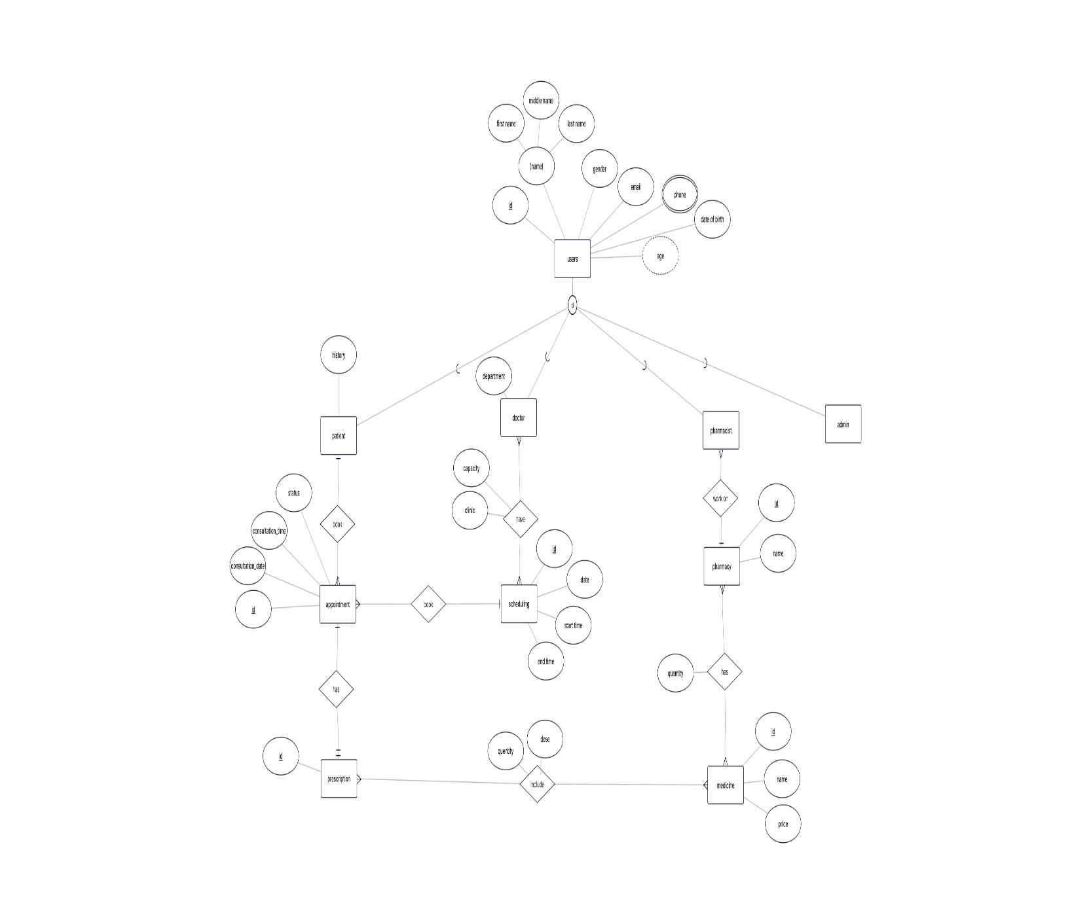

3.5 Database Mapping
Database mapping transforms the ERD into relational database tables.

Users Table
Column | Data Type
id | INT (PK)
first_name | VARCHAR(50)
middle_name | VARCHAR(50)
last_name | VARCHAR(50)
email | VARCHAR(100)
phone | VARCHAR(20)
gender | VARCHAR(10)
birth_date | DATE
password | VARCHAR(255)
role | VARCHAR(20)

Patient Table
Column | Data Type
patient_id | INT (PK)
user_id | INT (FK)
history | TEXT
address | VARCHAR(255)
emergency_contact | VARCHAR(50)

Doctor Table
Column | Data Type
doctor_id | INT (PK)
user_id | INT (FK)
department | VARCHAR(100)
clinic | VARCHAR(100)
capacity | INT

Pharmacist Table
Column | Data Type
pharmacist_id | INT (PK)
user_id | INT (FK)

Admin Table
Column | Data Type
admin_id | INT (PK)
user_id | INT (FK)

Appointment Table
Column | Data Type
appointment_id | INT (PK)
patient_id | INT (FK)
schedule_id | INT (FK)
consultation_date | DATE
consultation_time | TIME
status | VARCHAR(30)

Scheduling Table
Column | Data Type
schedule_id | INT (PK)
doctor_id | INT (FK)
date | DATE
start_time | TIME
end_time | TIME

Prescription Table
Column | Data Type
prescription_id | INT (PK)
appointment_id | INT (FK)

Medicine Table
Column | Data Type
medicine_id | INT (PK)
name | VARCHAR(100)
price | DECIMAL(10,2)

Pharmacy Table
Column | Data Type
pharmacy_id | INT (PK)
name | VARCHAR(100)

Prescription_Medicine Table
Column | Data Type
prescription_id | INT (FK)
medicine_id | INT (FK)
quantity | INT
dose | VARCHAR(100)

Pharmacy_Medicine Table
Column | Data Type
pharmacy_id | INT (FK)
medicine_id | INT (FK)
quantity | INT

3.6 Summary
This chapter presented the system design of the Salamtak Healthcare Management System. It described the component architecture, class structure, entity relationships, and database mapping. The design provides a scalable and maintainable foundation for implementing healthcare management functionalities while ensuring efficient data management and system performance.

Chapter 4
System Implementation and Testing

4.1 Introduction
This chapter presents the implementation and testing of the Salamtak Healthcare Management System. The system was developed using modern web technologies to provide an efficient healthcare management platform for patients, doctors, pharmacists, and administrators.
The implementation phase involved developing the user interface, backend logic, database integration, authentication mechanisms, and role-based access control. After implementation, several testing procedures were conducted to ensure that all system functionalities work correctly and meet user requirements.

4.2 Development Environment
The Salamtak Healthcare Management System was developed using the following tools and technologies:
Component | Technology
Programming Language | Python
Backend Framework | Flask
Frontend | HTML, CSS, Bootstrap
Database | SQL Server
IDE | Visual Studio Code
Version Control | Git
Operating System | Windows 10/11

4.3 System Implementation
The system consists of several modules that work together to provide healthcare management services.

4.3.1 Login Module
The login module allows users to access the system using their username and password.

Features
- User authentication
- Password verification
- Session management
- Role-based redirection

Process Flow
- User enters username and password.
- System validates credentials.
- User role is identified.
- System redirects to the appropriate dashboard.

Figure 4.1 Login Page
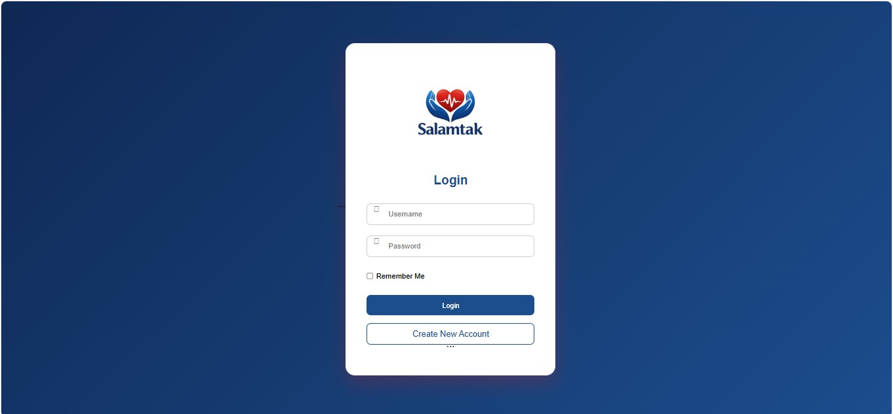

4.3.2 Registration Module
The registration module allows new patients to create accounts.

Features
- Personal information entry
- Email registration
- Password creation
- Data validation

Collected Information
- First Name
- Middle Name
- Last Name
- Email
- Phone Number
- Gender
- Birth Date
- Address
- Emergency Contact
- Password

Figure 4.2 Registration Page

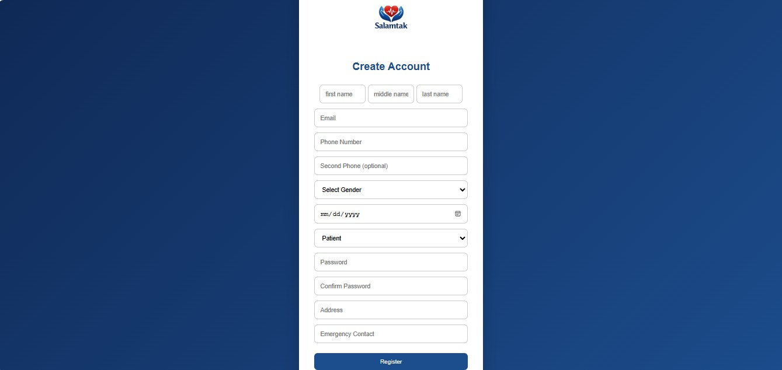

4.3.3 Admin Dashboard
The administrator dashboard provides complete system control.

Functions
- View all users
- Add new users
- Manage doctors
- Manage departments
- View appointments
- Manage pharmacy stock
- View prescriptions

Dashboard Statistics
- Total Users
- Total Doctors
- Total Appointments
- Total Medicines

Figure 4.3 Admin Dashboard

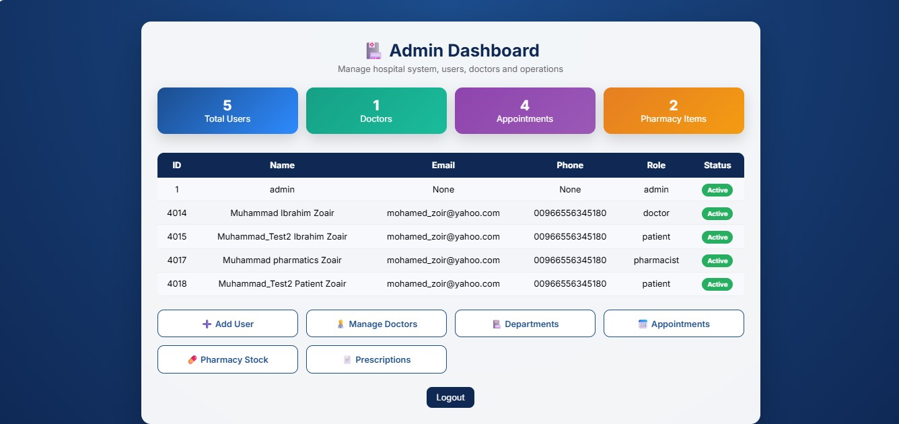

4.3.4 Doctor Dashboard
The doctor dashboard enables doctors to manage healthcare services.

Functions
- View patients
- View appointments
- Manage prescriptions

Dashboard Statistics
- Number of Patients
- Number of Appointments
- Number of Prescriptions

Figure 4.4 Doctor Dashboard

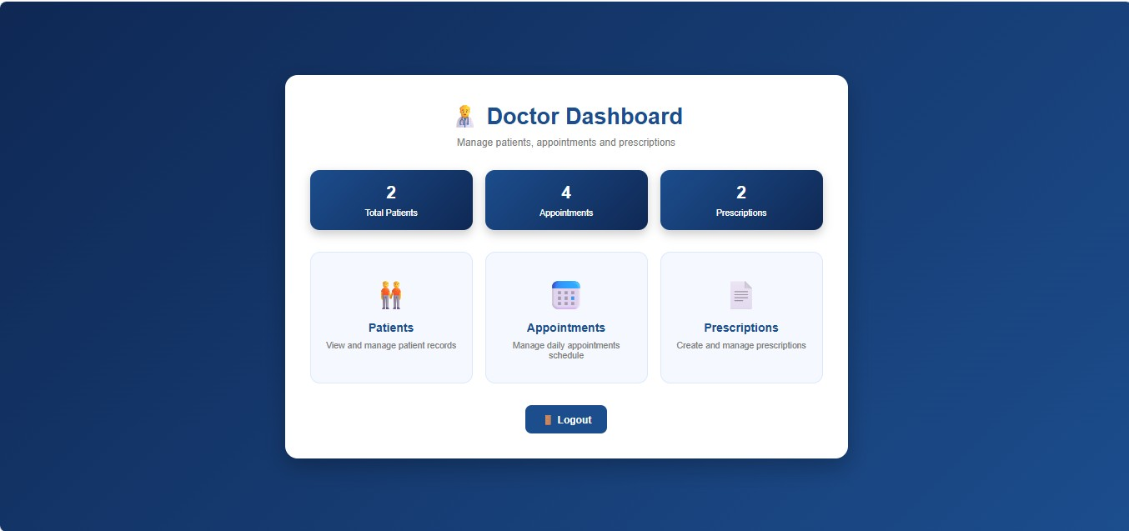

4.3.5 Pharmacist Dashboard
The pharmacist dashboard manages pharmacy operations.

Functions
- Manage medicine stock
- View prescriptions
- Update medicine quantities

Figure 4.5 Pharmacist Dashboard

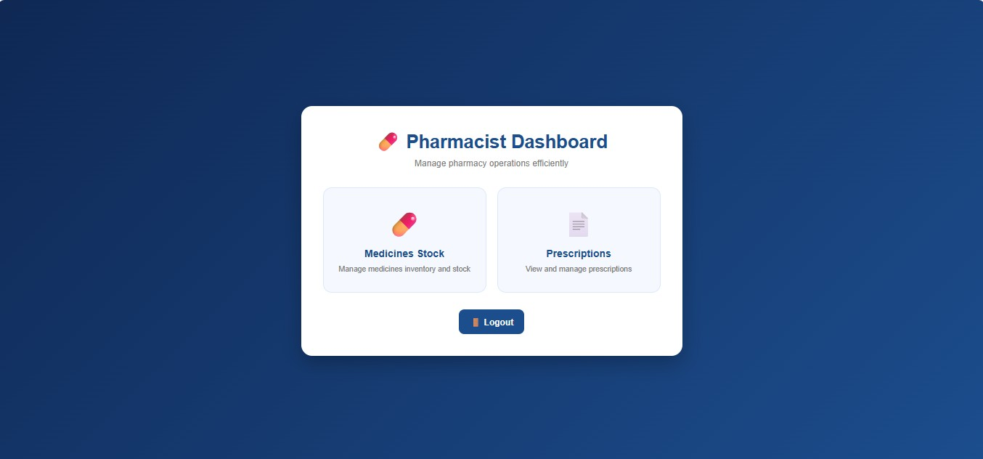

4.3.6 Patient Dashboard
The patient dashboard provides healthcare services to patients.

Functions
- Book appointments
- View appointments
- View prescriptions
- Manage profile information

Figure 4.6 Patient Dashboard

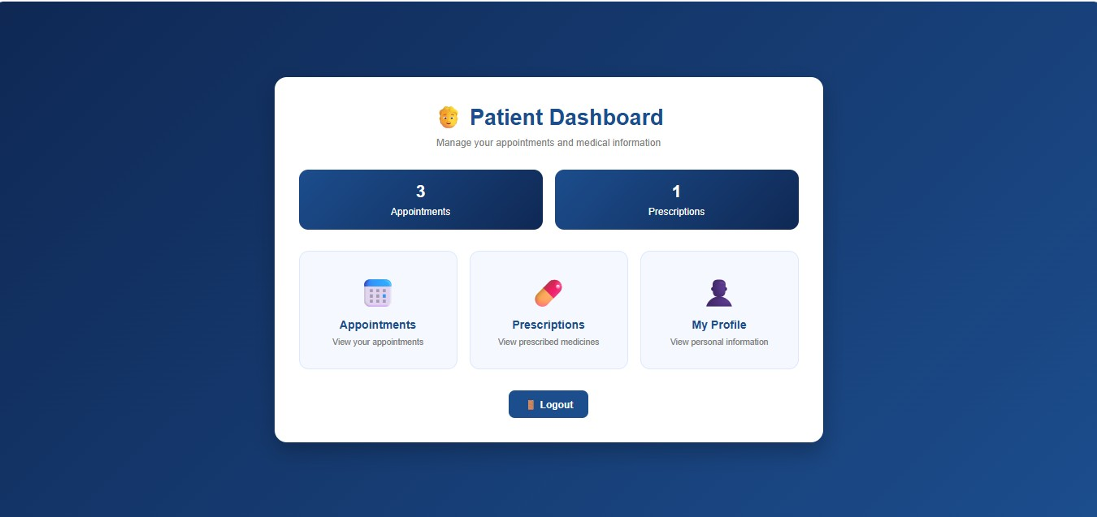

4.4 Testing
Testing was performed to verify that the system functions correctly and satisfies user requirements.
The following testing approaches were used:
- Functional Testing
- User Acceptance Testing (UAT)
- Interface Testing
- Database Testing

4.5 User Acceptance Testing (UAT)
User Acceptance Testing was conducted to ensure that the system satisfies the requirements of administrators, doctors, pharmacists, and patients.
The test scenarios covered all major system functionalities.

4.6 Test Cases

Test Case 1: User Login
Item | Description
Test Case ID | TC-01
Module | Login
Objective | Verify user login
Input | Valid username and password
Expected Result | User redirected to dashboard
Actual Result | Successful
Status | Pass

Test Case 2: Invalid Login
Item | Description
Test Case ID | TC-02
Module | Login
Objective | Verify invalid credentials
Input | Incorrect password
Expected Result | Error message displayed
Actual Result | Successful
Status | Pass

Test Case 3: User Registration
Item | Description
Test Case ID | TC-03
Module | Registration
Objective | Create patient account
Input | Valid registration data
Expected Result | Account created successfully
Actual Result | Successful
Status | Pass

Test Case 4: View Admin Dashboard
Item | Description
Test Case ID | TC-04
Module | Admin
Objective | Verify dashboard loading
Input | Admin account
Expected Result | Dashboard displayed
Actual Result | Successful
Status | Pass

Test Case 5: View Doctor Dashboard
Item | Description
Test Case ID | TC-05
Module | Doctor
Objective | Verify doctor dashboard
Input | Doctor account
Expected Result | Dashboard displayed
Actual Result | Successful
Status | Pass

Test Case 6: View Pharmacist Dashboard
Item | Description
Test Case ID | TC-06
Module | Pharmacist
Objective | Verify pharmacist dashboard
Input | Pharmacist account
Expected Result | Dashboard displayed
Actual Result | Successful
Status | Pass

Test Case 7: Add New User
Item | Description
Test Case ID | TC-07
Module | User Management
Objective | Add user
Input | Valid user information
Expected Result | User added successfully
Actual Result | Successful
Status | Pass

Test Case 8: Manage Medicine Stock
Item | Description
Test Case ID | TC-08
Module | Pharmacy
Objective | Update medicine inventory
Input | Medicine quantity
Expected Result | Stock updated
Actual Result | Successful
Status | Pass

Test Case 9: View Prescriptions
Item | Description
Test Case ID | TC-09
Module | Prescription
Objective | View prescriptions
Input | Authorized user
Expected Result | Prescription list displayed
Actual Result | Successful
Status | Pass

Test Case 10: Book Appointment
Item | Description
Test Case ID | TC-10
Module | Appointment
Objective | Book appointment
Input | Valid appointment information
Expected Result | Appointment recorded successfully
Actual Result | Successful
Status | Pass

4.7 Testing Summary
The testing results demonstrate that the Salamtak Healthcare Management System successfully satisfies the specified functional requirements. All critical modules, including authentication, user management, appointment management, prescription handling, and pharmacy operations, performed as expected during testing. The User Acceptance Testing results indicate that the system is reliable, user-friendly, and suitable for deployment in healthcare environments.

Chapter 5
Conclusion and Future Work

5.1 Introduction
This chapter summarizes the work accomplished in the development of the Salamtak Healthcare Management System and highlights the project's contributions, achievements, limitations, and possible future enhancements. The chapter also evaluates how the system fulfills the requirements identified during the analysis and design phases.

5.2 Project Summary
The Salamtak Healthcare Management System was developed as a web-based healthcare platform that integrates patients, doctors, pharmacists, and administrators into a single system. The project aimed to improve healthcare service management by replacing traditional manual processes with an efficient digital solution.
The system was implemented using the Flask Framework and SQL Server Database while providing a user-friendly web interface developed with HTML and CSS. Through role-based access control, each user category can access the functionalities relevant to its responsibilities.
The main modules implemented in the system include:
- User Registration and Authentication
- Patient Management
- Doctor Management
- Appointment Scheduling
- Prescription Management
- Pharmacy Management
- Medicine Inventory Control
- Administrative Dashboard and Reporting

These modules work together to provide an integrated healthcare environment that facilitates communication and data sharing among healthcare stakeholders.

5.3 Achievements
The project successfully achieved its primary objectives by providing a centralized healthcare management platform. The major achievements include:

User Authentication and Security
- Secure login and registration mechanisms.
- Password encryption using hashing techniques.
- Session-based authentication.
- Role-based authorization.

Appointment Management
- Patients can book appointments online.
- Doctors can view and manage appointments.
- Appointment conflicts are prevented through validation.

Prescription Management
- Doctors can create prescriptions for patients.
- Patients can view their prescriptions.
- Pharmacists can access prescriptions for medication dispensing.

Pharmacy Management
- Medicine inventory management.
- Adding, updating, and deleting medicines.
- Viewing prescription records.

Administrative Control
- Managing users.
- Managing doctors.
- Managing departments.
- Monitoring appointments.
- Managing pharmacy operations.

Database Integration
- Efficient storage and retrieval of healthcare data.
- Secure management of patient and medical information.
- Relational database design based on the ERD model.

5.4 Evaluation of Objectives
The objectives defined at the beginning of the project were successfully achieved.
Objective | Status
User Authentication | Achieved
Patient Registration | Achieved
Appointment Booking | Achieved
Prescription Management | Achieved
Medicine Management | Achieved
Administrative Dashboard | Achieved
Database Integration | Achieved
Role-Based Access Control | Achieved
The testing results demonstrated that the system performs its intended functions effectively and meets user requirements.

5.5 Challenges Faced
During the development process, several challenges were encountered.

Database Design Complexity
Designing relationships between users, doctors, patients, appointments, prescriptions, and medicines required careful planning to ensure data consistency and integrity.

Authentication and Authorization
Implementing role-based access control required proper session management and route protection to ensure that users only access authorized resources.

User Interface Design
Creating responsive and user-friendly interfaces for different user roles required continuous refinement and testing.

Integration Between Modules
Ensuring smooth communication between appointment management, prescription generation, and pharmacy operations required extensive debugging and validation.
Despite these challenges, all major issues were successfully resolved during development.

5.6 Limitations of the Current System
Although the system fulfills its primary objectives, several limitations still exist.

Limited Reporting Features
The system currently provides basic dashboards and statistics but does not generate advanced analytical reports.

No Online Payment Integration
Patients cannot pay consultation fees through the system.

No Mobile Application
The current implementation is web-based only.

Limited Prescription Details
Prescriptions currently contain basic information and do not include advanced medication management features.

No Real-Time Notifications
The system does not currently provide SMS, email, or push notifications for appointments and prescriptions.

5.7 Future Work
Several enhancements can be implemented in future versions of the Salamtak Healthcare Management System to improve functionality and user experience.

Mobile Application Development
Develop Android and iOS applications to allow users to access healthcare services through mobile devices.

Online Payment System
Integrate secure payment gateways for appointment booking and healthcare service payments.

Video Consultation
Implement telemedicine features that allow doctors and patients to conduct online consultations through video conferencing.

Artificial Intelligence Integration
Introduce AI-based healthcare services such as:
- Disease prediction
- Symptom analysis
- Treatment recommendations
- Medical decision support

Notification System
Add:
- SMS notifications
- Email reminders
- Appointment alerts
- Prescription reminders

Electronic Medical Records (EMR)
Expand patient records to support complete electronic medical history management.

Advanced Reporting and Analytics
Provide administrators with:
- Healthcare statistics
- Performance indicators
- Appointment trends
- Pharmacy inventory reports

Cloud Deployment
Deploy the system on cloud platforms such as:
- Microsoft Azure
- Amazon Web Services (AWS)
- Google Cloud Platform (GCP)
to improve scalability, availability, and security.

5.8 Conclusion
The Salamtak Healthcare Management System successfully demonstrates the application of software engineering principles, database management techniques, and web development technologies in solving real-world healthcare management problems.
The system provides an integrated environment for patients, doctors, pharmacists, and administrators, improving efficiency, reducing paperwork, and enhancing communication among healthcare participants. Through the use of Flask, SQL Server, HTML, and CSS, the project delivers a secure and reliable platform capable of managing essential healthcare operations.
The successful implementation and testing of the system confirm that the project objectives have been achieved. Furthermore, the proposed future enhancements provide opportunities for

extending the system into a comprehensive healthcare solution capable of supporting larger healthcare institutions and modern digital healthcare services.

References
- Flask Documentation. Available at: https://flask.palletsprojects.com/
- Microsoft SQL Server Documentation. Available at: https://learn.microsoft.com/sql/
- Python Software Foundation. Available at: https://www.python.org/
- ERD Plus Database Modeling Tool. Available at: https://erdplus.com/

